Image links

<https://uxwing.com/text-message-icon>

<https://unsplash.com/photos/iIn8IKBOva0>

<https://unsplash.com/photos/GWkioAj5aB4>

<https://unsplash.com/photos/0VGG7cqTwCo>

<https://unsplash.com/photos/y_6rqStQBYQ>

<https://unsplash.com/photos/npTT9rD8wd4>

<https://unsplash.com/photos/NZeMMrsUu7M>

<https://unsplash.com/photos/9_SaFlgwFdA>

Tags to use

* Caption
* Cite
* TH for table header
* Video – embed video
* Download attribute

# HOME PAGE

Intro

The ease of use of instant messaging (IM) has made it a popular tool for business communication. It allows employees to communicate and collaborate in real-time, improving their efficiency. However, instant messaging can bring about concerns regarding productivity, security, and privacy. Therefore, businesses must find ways to maximise the benefits while mitigating these potential drawbacks.

This website contains information that will inform businesses on how to effectively utilise instant messaging to enhance communication and collaboration within the organisation while mitigating the associated risks.

The focus is on three key aspects: the current usage of instant messaging in businesses, effective implementation and adoption strategies for integrating instant messaging into workflows and what the future of instant messaging in businesses will look like.

Answer

Instant messaging is a popular tool for communication within businesses due to its many benefits. The implementation of instant messaging within businesses has a predominantly positive impact on communication and collaboration. Instant messaging promotes interactivity and trust among team members, enhancing teamwork.

Despite occasional issues, most users are satisfied with their instant messaging applications, reflecting their positive impact. The benefits of real-time collaboration and instant message delivery outweigh concerns regarding security and productivity. To realise these benefits, businesses must select secure instant messaging platforms and promote work-life balance among their employees.

In the future, AI chatbots integrated into instant messaging platforms are set to revolutionise communication with customers, reducing wait times and increasing satisfaction. Furthermore, instant messaging tools designed specifically for businesses, like WhatsApp Business, are seeing significant growth.

Overall, instant messaging plays a vital role in enhancing communication and fostering collaboration within businesses. By adhering to best practices and embracing technological advancements, organisations can strengthen their communication between team members and build stronger relationships with clients. As a result, this leads to improved productivity and success in today’s business environment.

# CURRENT PAGE

Instant messaging (IM) is already widely used in many businesses. It has been proven to have an overwhelmingly positive impact on communication quality and trust within teams (Ou & Davison, 2010). This tool plays a crucial role in developing trust and promoting interactivity among team members, ultimately leading to improved teamwork and collaboration. With numerous instant messaging platforms for businesses to choose from, including both paid and free options, businesses can choose a platform that best suits their needs.

Research indicates that most users are content with their instant messaging applications. The average satisfaction rating of survey respondents was 4 out of 5. The average rating of paid IM apps on the App Store is 4,6 out of 5 stars, while free apps average a rating of 4,2 stars. However, some free options such as Signal and Microsoft Teams outperform their paid counterparts with ratings of 4,8 stars. This shows that any business can benefit from the advantages of IM, without any capital investment.

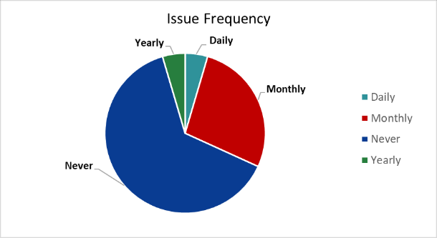

**Figure 1:** How frequently people experience issues with instant messaging

Although some users still experience issues with instant messaging applications (see above), these issues are experienced by less than 50% of users. However, businesses should still be aware of them. Common issues include connectivity problems and load shedding affecting communication.

Despite the differences between instant messaging platforms, they all share these general advantages and disadvantages:

|  |  |
| --- | --- |
| Advantages | Disadvantages |
| Instant delivery of messages | Both parties need accounts on the same messaging service |
| Messages tend to be brief and to the point, especially compared to email | Security and privacy can be compromised |
| Real-time conversation allows for collaboration between co-workers, even in different locations | Pop-up notifications can be intrusive and distracting, decreasing productivity |

Expanding on the above table, research has shown that the idea that instant messaging drastically decreases productivity is a misconception (Ou & Davison, 2010). You can read more about that study on [www.researchgate.net](https://www.researchgate.net/publication/282781192_The_impact_of_instant_messaging_in_the_workplace). The remarkable benefits such as instant delivery of messages and real-time collaboration opportunities outweigh the security, privacy, and productivity concerns in most cases. That is why instant messaging currently has a predominantly positive impact on businesses and should continue to be embraced.

# IMPLEMENTATION PAGE

Businesses cannot follow a haphazard approach when implementing instant messaging into their daily workflows. Otherwise, the issues relating to privacy, security and productivity may be detrimental to businesses’ operations.

Here are some best practices that businesses should adhere to:

* Adopt tools that are already familiar to employees to ensure more seamless integration.
* Establish ground rules that minimize distractions and mental health concerns.
* Clearly define protocols to deal with these issues if they arise.
* Encourage face-to-face communication by hosting events or using video conferencing.
* Respect the work/life balance of employees (to comply with legal requirements and to allow employees time to relax so that they can work more effectively).

You can watch this interview about the legality around instant messaging in businesses:

<insert video>

Another important point to consider when integrating instant messaging into a business is security.

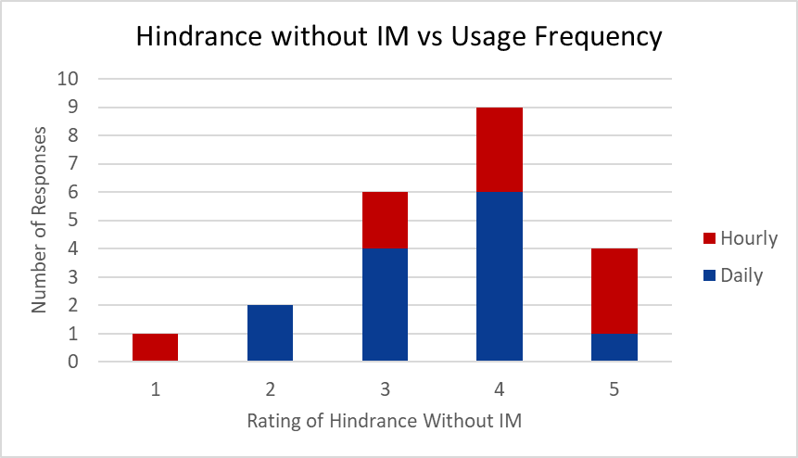

**Figure 1:** How hindered people will be without instant messaging, compared to how often they use it

Although most people feel that they would be significantly hindered if they were not able to use instant messaging to do their jobs (see above), people also feel that instant messaging applications are generally not very secure. The average security rating by survey respondents was 3,64 out of 5 (you can download the results of that survey here). This is concerning, as many sensitive documents are shared over instant messaging during collaboration. For these reasons, businesses should be very careful when selecting an application for their organisation to use. Some are proven to be much more secure than others.

If businesses follow these best practices, the implementation of instant messaging applications is more likely to yield favourable results.

# FUTURE PAGE

Although instant messaging is already widely used in businesses and is proven to have a positive impact, certain new technologies and innovations are certain to enhance this impact even further.

The integration of AI (artificial intelligence) into messaging applications is a significant development, enabling users to engage with AI alongside humans. This can reduce the reliance of businesses on human resources for tasks such as customer service, as AI can handle general inquiries (Fokina, 2022).

AI chatbots have already been implemented to reduce customer wait times and allow businesses to handle large volumes of support requests. Integrating these automated systems into a business would relieve the workload of customer support agents, allowing them to handle more complex inquiries which have been escalated by the chatbots. For these reasons, AI is set to revolutionise the way businesses interact with customers over instant messaging.

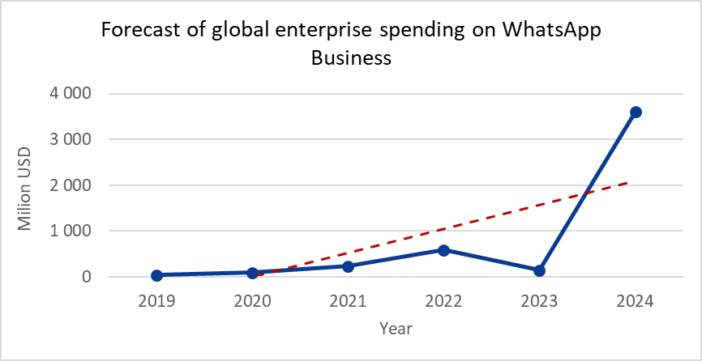If you would like to read more about AI in customer service, visit <https://learn.g2.com/ai-in-customer-service>.

**Figure 5:** Forecast of global enterprise spending on WhatsApp Business

Additionally, business-focused instant messaging platforms like WhatsApp Business, which allow businesses to communicate directly with their clients, will see immense growth over the coming years (see above). This year-on-year growth in spending shows how much faith businesses have in this tool, as well as others like it.

Finally, businesses need to remember that other communication methods still have their place (Kumar, 2019). Email, for instance, remains widely utilized as it facilitates messages to large groups, albeit with potential drawbacks such as its susceptibility to spam and malware. Furthermore, in urgent situations, phone calls remain the optimal choice.

These innovations, and others that are yet to be developed, are sure to have an overwhelmingly positive impact on communication with customers and clients.

[](https://www.pexels.com/photo/a-woman-in-a-tank-top-using-a-vr-headset-8721318/)**Figure 7:** Woman using virtual reality, another new technology like AI